UNDERSTANDING THE DATA:
The dataset used for this project is the “Ecommerce Customer Churn Analysis" and Prediction dataset created by Ankit Verma and published on Kaggle. It contains 5,630 observations and 20 variables describing transactional behavior, customer experience, demographic characteristics, and platform engagement patterns. The dataset is synthetic, meaning it imitates real customer distributions without exposing actual private data.

MISSING VALUES IN THE ORIGINAL DATASET:
The original Excel dataset contains missing values across several key behavioral fields:
• Tenure: 264 missing (4.69 percent)
• WarehouseToHome: 251 missing (4.46 percent)
• HourSpendOnApp: 255 missing (4.53 percent)
• OrderAmountHikeFromLastYear: 265 missing (4.71 percent)
• CouponUsed: 256 missing (4.55 percent)
• OrderCount: 258 missing (4.58 percent)
• DaySinceLastOrder: 307 missing (5.45 percent)
All other variables contain 0 missing values. This pattern aligns with common ecommerce data challenges, where behavioral logs and transactional timestamps are more error‑prone than demographic records.
THE IMPUTED SOLUTION:
The imputed dataset used for modeling contains zero missing values, meaning an imputation step has been applied before analysis. This produces a clean, ready‑to‑model dataset but removes important uncertainty about customer behavior. Because imputation hides where gaps originally appeared, analysts must remain cautious about interpreting results, particularly for variables that had more than 5 percent missingness.

KEY STATISTICS FROM THE IMPUTED DATA:
• Churn rate: 16.8 percent
• Average tenure: 10.1 months (range 0–61 months)
• Average satisfaction score: 3.07
• Complaint rate: 28.5 percent
• Average orders per customer: 3.0
• Average daily time on app: 2.93 hours
• Average cashback amount: 177.2 units
City tier distribution shows that approximately 65 percent of customers come from Tier‑1 cities and 31 percent from Tier‑3 cities. Gender distribution is approximately 60 percent male and 40 percent female. These patterns reflect realistic ecommerce segmentation categories.
HOW REAL BUSINESSES OBTAIN THIS DATA:
In a real company like 2REN, customer‑level data would be gathered from:
• Web and mobile analytics systems (engagement, device information)
• Order management system (order count, values, recency)
• CRM platform (tenure, demographics, addresses)
• Payment gateway (payment mode, success/failure)
• Customer support system (tickets, complaints, satisfaction)

Data engineers maintain automated ETL (extract, transform, load) pipelines that feed a central data warehouse or lake. Analysts then use warehouse tables to construct modeling datasets following CRISP‑DM.
LIMITATIONS OF SYNTHETIC AND IMPUTED DATA:
Synthetic data is extremely useful for teaching, experimentation, and prototyping, but it contains several limitations:
• No real-world noise such as inconsistent formatting or duplicated customer IDs
• Artificial distributions that may not represent 2REN’s true customer base
• Uncertain causal relationships
• Limited temporal detail such as missing transaction timelines or seasonality
• Imputation removes information about original uncertainty
Because of these constraints, the dataset should be viewed as a learning artifact. Real deployment requires repeating CRISP‑DM’s Data Understanding and Data Preparation phases on actual operational data.

VARIABLE MAPPING TO BUSINESS PROBLEM:
Each field contributes directly to understanding churn

Dataset Variable | Business Meaning | Why It Matters for Churn
Churn | Whether the customer left the platform | Target variable used to train the model
Tenure | Months customer has stayed | Longer tenure usually predicts lower churn
City Tier | Customer geography | Helps segment churn patterns by region
Gender | Demographic attribute | Used to see differences in retention behavior
Marital Status | Household indicator | Can shape spending stability
Preferred Payment Mode | How customer typically pays | Friction in payment choices can drive churn
Order Count | Total orders made | Core indicator of engagement and loyalty
Days Since Last Order | Recency of activity | One of the strongest churn warning signals
Cashback Amount | Value of incentives earned | Affects satisfaction and purchase motivation
Satisfaction Score | Customer sentiment | Dissatisfied customers churn faster
Complain | Whether customer raised a complaint | Complaints predict early churn if unresolved
Time on App | App usage time | Higher engagement lowers churn risk
Preferred Login Device | Mobile vs desktop etc. | Helps tailor retention experience across devices

DATA INFRASTRUCTURE:

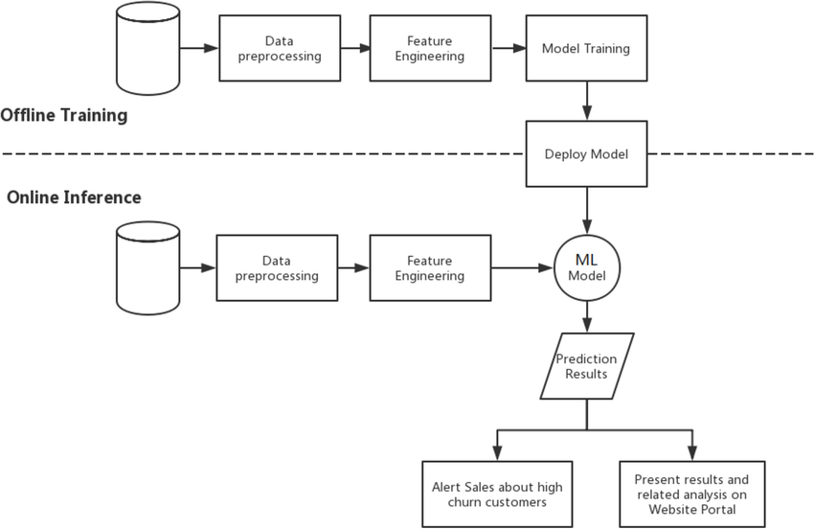

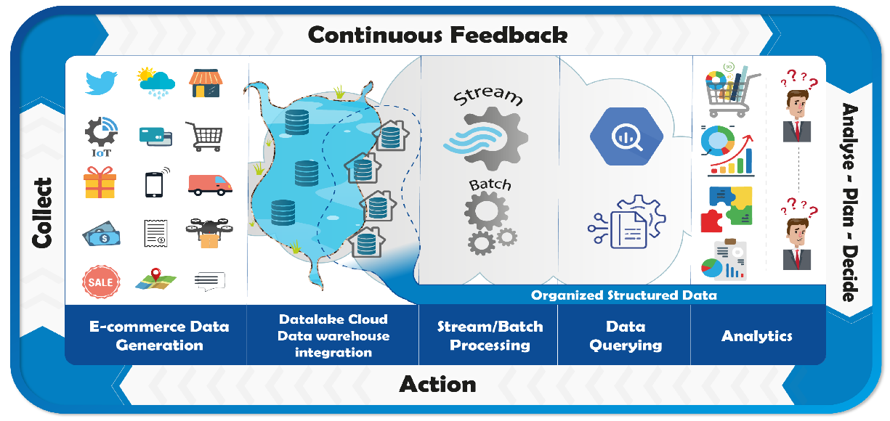
Figure 1. Data Flow for Churn Analytics Infrastructure

EXPLANATION OF THE FLOW:
Customer interactions generate behavioral, transactional, and experience data. These flow into operational systems like CRM, order management, and mobile analytics. A centralized data warehouse integrates these sources into a structured dataset. The analytics environment performs feature engineering, model training, and scoring. Predictions feed business systems that run retention campaigns.

DATA ACQUISITION STRATEGY:
Organizational foundation:
2REN requires cross-departmental coordination to source the correct data. Marketing, IT, customer experience, and finance must align on definitions such as “active customer,” “churn,” and “engagement frequency.” Clear ownership ensures consistency and avoids conflicting interpretations.

Functional foundation:
Customer data collection supports multiple functions: targeted retention, loyalty program optimization, service improvement, and proactive communication. The dataset’s behavioral and satisfaction components directly impact CX workflows.

Technological foundation
E-commerce companies typically use data warehouse layered on cloud storage, CRM tools like Zendesk or Salesforce, and event-tracking platforms such as Google Analytics or Mix panel. These systems enable structured ingestion, automated ETL pipelines, and scheduled model scoring.

REFERENCES
Boyatzis, R. E., Smith, M. L., & Van Oosten, E. (2013). Developing resonant leaders through emotional intelligence, vision, and coaching. Jossey-Bass.
Choi, S. (2007). Democratic leadership: The lessons of exemplary models for democratic governance. International Journal of Leadership Studies, 2(3), 243–262.
Collier, K. (2012). Agile analytics: A value-driven approach to business intelligence and data warehousing. Pearson Education.
Davenport, T. H. (2018). The AI advantage: How to put the artificial intelligence revolution to work. MIT Press.

